THE INSTITUTE OF CIVIL ENGINEERS & ARCHITECTS - SURAT

RECENT PASSPORT SIZE PHOTO
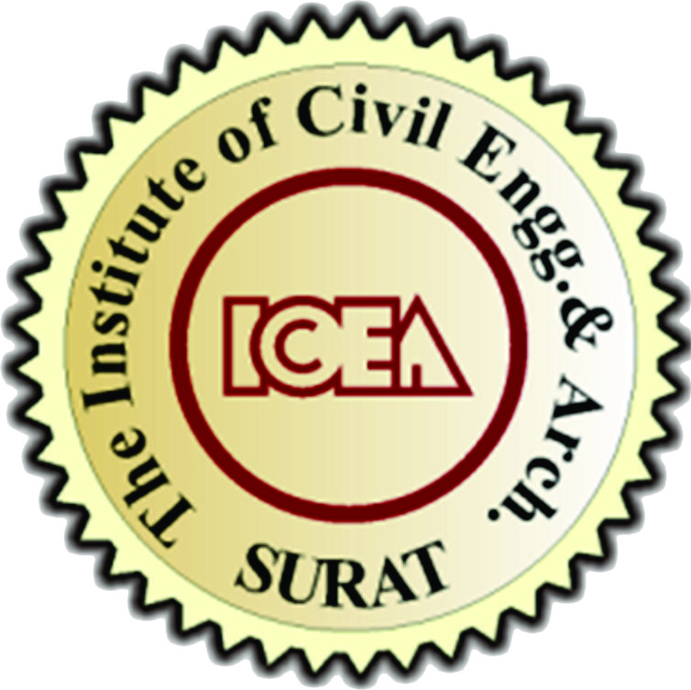 DATA SHEET
NAME : ___________________________________________________________
DATE OF BIRTH : ___________________________________________________________
DEGREE : ___________________________________________________________
PROFFESSION : ___________________________________________________________
FIRM : ___________________________________________________________
OFFICE ADDRESS : ___________________________________________________________
___________________________________________________________
___________________________________________________________
RESI.ADDRESS : ___________________________________________________________
___________________________________________________________
___________________________________________________________
CONTACT
(Mob.) : _______________________________________
(Office) : _______________________________________
(Resi.) : _______________________________________
(Email Id.) : _______________________________________
(Blood Group) : _______________________________________
(Wedding Date) : _______________________________________
NAME DOB BLOOD GROUP
SPOUCE : ___________________________________________________________
KIDS : ___________________________________________________________
: ___________________________________________________________
: ___________________________________________________________
: ___________________________________________________________
Return this form dully filled before 10/12/2015.

